|  |
| --- |
| The SAS System |

The REG Procedure

Model: MODEL1

Dependent Variable: Crime

|  |  |
| --- | --- |
| **Number of Observations Read** | 47 |
| **Number of Observations Used** | 47 |

| **Analysis of Variance** | | | | | |
| --- | --- | --- | --- | --- | --- |
| **Source** | **DF** | **Sum of Squares** | **Mean Square** | **F Value** | **Pr > F** |
| **Model** | 1 | 55084 | 55084 | 0.36 | 0.5498 |
| **Error** | 45 | 6825844 | 151685 |  |  |
| **Corrected Total** | 46 | 6880928 |  |  |  |

|  |  |  |  |
| --- | --- | --- | --- |
| **Root MSE** | 389.46812 | **R-Square** | 0.0080 |
| **Dependent Mean** | 905.08511 | **Adj R-Sq** | -0.0140 |
| **Coeff Var** | 43.03110 |  |  |

| **Parameter Estimates** | | | | | |
| --- | --- | --- | --- | --- | --- |
| **Variable** | **DF** | **Parameter Estimate** | **Standard Error** | **t Value** | **Pr > |t|** |
| **Intercept** | **1** | 1286.64557 | 635.71689 | 2.02 | 0.0489 |
| **M** | **1** | -27.53469 | 45.69193 | -0.60 | 0.5498 |

|  |
| --- |
| The SAS System |

The REG Procedure

Model: MODEL1

Dependent Variable: Crime

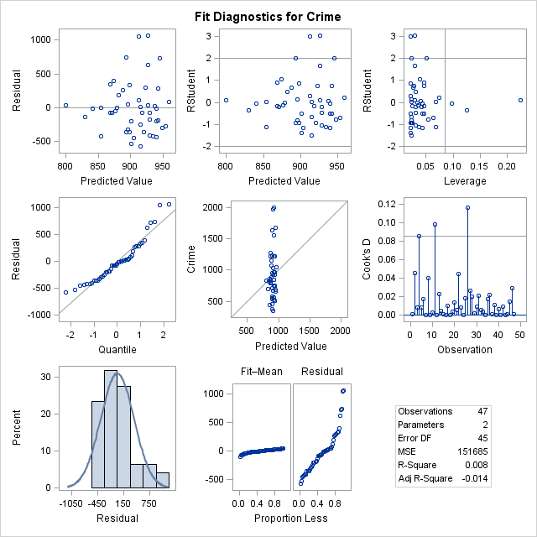

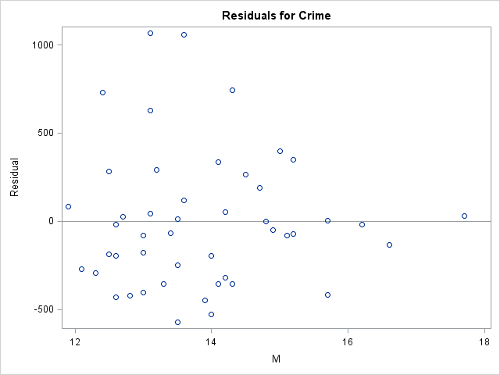

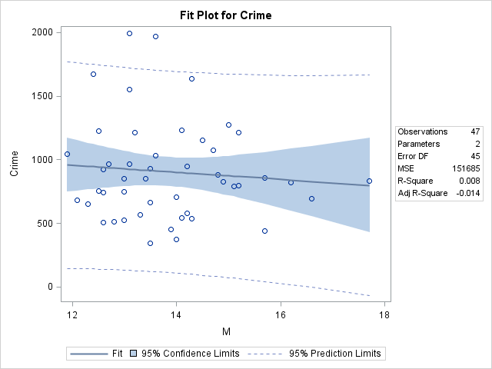

|  |
| --- |
| The SAS System |

The REG Procedure

Model: MODEL1

Dependent Variable: Crime

|  |  |
| --- | --- |
| **Number of Observations Read** | 47 |
| **Number of Observations Used** | 47 |

| **Analysis of Variance** | | | | | |
| --- | --- | --- | --- | --- | --- |
| **Source** | **DF** | **Sum of Squares** | **Mean Square** | **F Value** | **Pr > F** |
| **Model** | 1 | 56527 | 56527 | 0.37 | 0.5446 |
| **Error** | 45 | 6824400 | 151653 |  |  |
| **Corrected Total** | 46 | 6880928 |  |  |  |

|  |  |  |  |
| --- | --- | --- | --- |
| **Root MSE** | 389.42694 | **R-Square** | 0.0082 |
| **Dependent Mean** | 905.08511 | **Adj R-Sq** | -0.0138 |
| **Coeff Var** | 43.02656 |  |  |

| **Parameter Estimates** | | | | | |
| --- | --- | --- | --- | --- | --- |
| **Variable** | **DF** | **Parameter Estimate** | **Standard Error** | **t Value** | **Pr > |t|** |
| **Intercept** | **1** | 930.00000 | 69.94314 | 13.30 | <.0001 |
| **So** | **1** | -73.18750 | 119.87651 | -0.61 | 0.5446 |

|  |
| --- |
| The SAS System |

The REG Procedure

Model: MODEL1

Dependent Variable: Crime

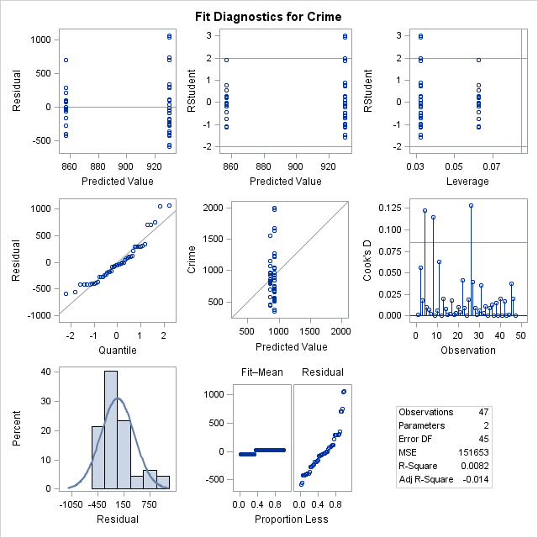

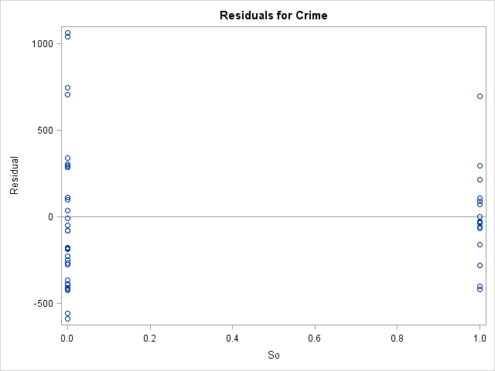

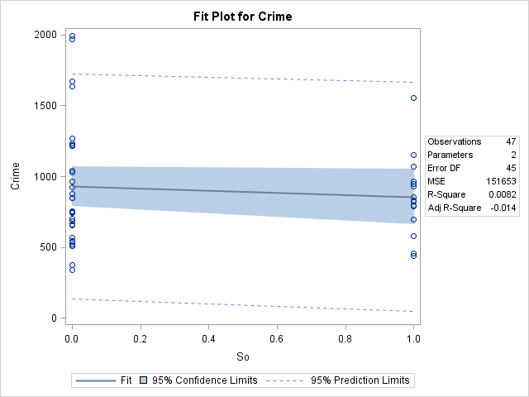

|  |
| --- |
| The SAS System |

The REG Procedure

Model: MODEL1

Dependent Variable: Crime

|  |  |
| --- | --- |
| **Number of Observations Read** | 47 |
| **Number of Observations Used** | 47 |

| **Analysis of Variance** | | | | | |
| --- | --- | --- | --- | --- | --- |
| **Source** | **DF** | **Sum of Squares** | **Mean Square** | **F Value** | **Pr > F** |
| **Model** | 1 | 717146 | 717146 | 5.24 | 0.0269 |
| **Error** | 45 | 6163781 | 136973 |  |  |
| **Corrected Total** | 46 | 6880928 |  |  |  |

|  |  |  |  |
| --- | --- | --- | --- |
| **Root MSE** | 370.09852 | **R-Square** | 0.1042 |
| **Dependent Mean** | 905.08511 | **Adj R-Sq** | 0.0843 |
| **Coeff Var** | 40.89102 |  |  |

| **Parameter Estimates** | | | | | |
| --- | --- | --- | --- | --- | --- |
| **Variable** | **DF** | **Parameter Estimate** | **Standard Error** | **t Value** | **Pr > |t|** |
| **Intercept** | **1** | -273.96654 | 518.10367 | -0.53 | 0.5996 |
| **Ed** | **1** | 111.61214 | 48.77810 | 2.29 | 0.0269 |

|  |
| --- |
| The SAS System |

The REG Procedure

Model: MODEL1

Dependent Variable: Crime

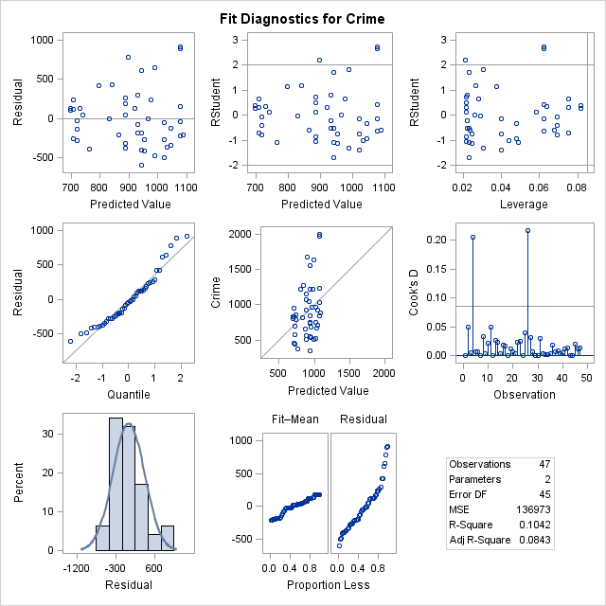

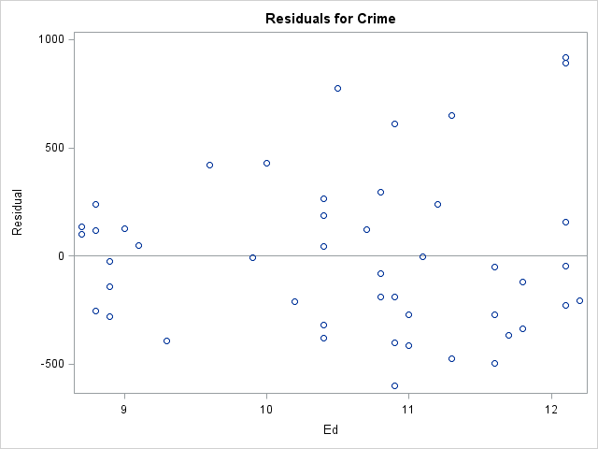

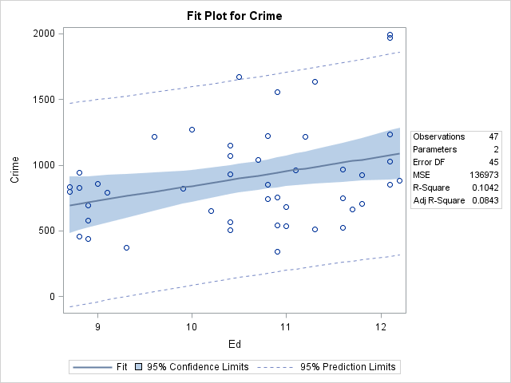

|  |
| --- |
| The SAS System |

The REG Procedure

Model: MODEL1

Dependent Variable: Crime

|  |  |
| --- | --- |
| **Number of Observations Read** | 47 |
| **Number of Observations Used** | 47 |

| **Analysis of Variance** | | | | | |
| --- | --- | --- | --- | --- | --- |
| **Source** | **DF** | **Sum of Squares** | **Mean Square** | **F Value** | **Pr > F** |
| **Model** | 1 | 3253302 | 3253302 | 40.36 | <.0001 |
| **Error** | 45 | 3627626 | 80614 |  |  |
| **Corrected Total** | 46 | 6880928 |  |  |  |

|  |  |  |  |
| --- | --- | --- | --- |
| **Root MSE** | 283.92588 | **R-Square** | 0.4728 |
| **Dependent Mean** | 905.08511 | **Adj R-Sq** | 0.4611 |
| **Coeff Var** | 31.37008 |  |  |

| **Parameter Estimates** | | | | | |
| --- | --- | --- | --- | --- | --- |
| **Variable** | **DF** | **Parameter Estimate** | **Standard Error** | **t Value** | **Pr > |t|** |
| **Intercept** | **1** | 144.46398 | 126.69256 | 1.14 | 0.2602 |
| **Po1** | **1** | 89.48484 | 14.08615 | 6.35 | <.0001 |

|  |
| --- |
| The SAS System |

The REG Procedure

Model: MODEL1

Dependent Variable: Crime

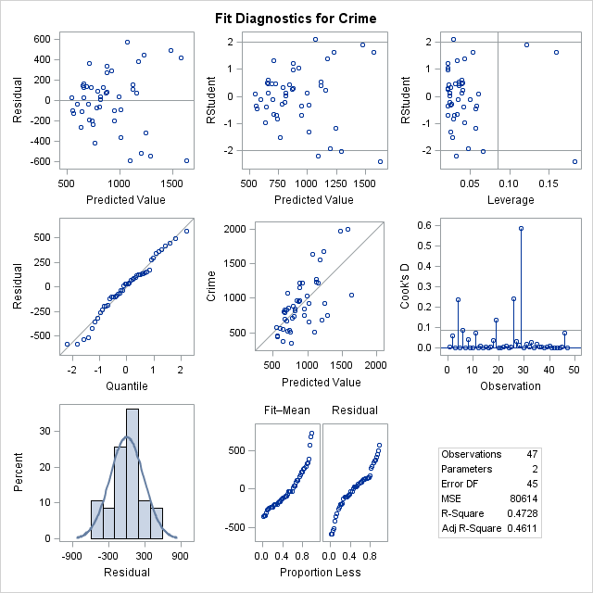

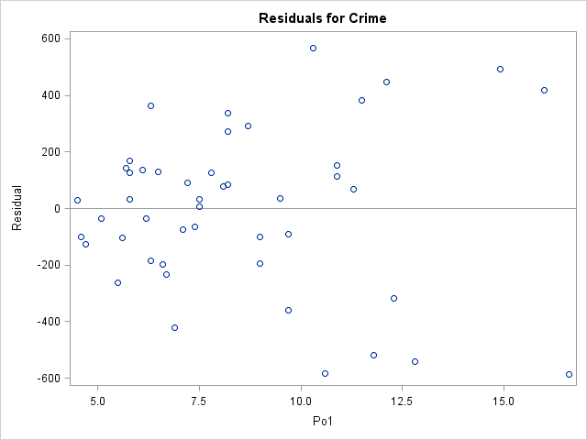

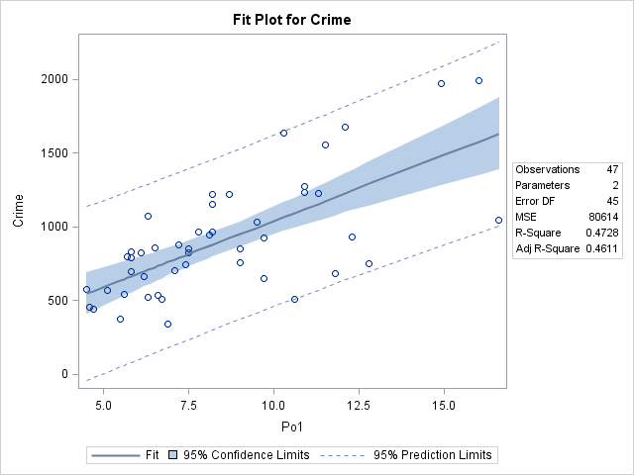

|  |
| --- |
| The SAS System |

The REG Procedure

Model: MODEL1

Dependent Variable: Crime

|  |  |
| --- | --- |
| **Number of Observations Read** | 47 |
| **Number of Observations Used** | 47 |

| **Analysis of Variance** | | | | | |
| --- | --- | --- | --- | --- | --- |
| **Source** | **DF** | **Sum of Squares** | **Mean Square** | **F Value** | **Pr > F** |
| **Model** | 1 | 3058626 | 3058626 | 36.01 | <.0001 |
| **Error** | 45 | 3822302 | 84940 |  |  |
| **Corrected Total** | 46 | 6880928 |  |  |  |

|  |  |  |  |
| --- | --- | --- | --- |
| **Root MSE** | 291.44475 | **R-Square** | 0.4445 |
| **Dependent Mean** | 905.08511 | **Adj R-Sq** | 0.4322 |
| **Coeff Var** | 32.20081 |  |  |

| **Parameter Estimates** | | | | | |
| --- | --- | --- | --- | --- | --- |
| **Variable** | **DF** | **Parameter Estimate** | **Standard Error** | **t Value** | **Pr > |t|** |
| **Intercept** | **1** | 165.16424 | 130.42697 | 1.27 | 0.2119 |
| **Po2** | **1** | 92.22031 | 15.36808 | 6.00 | <.0001 |

|  |
| --- |
| The SAS System |

The REG Procedure

Model: MODEL1

Dependent Variable: Crime

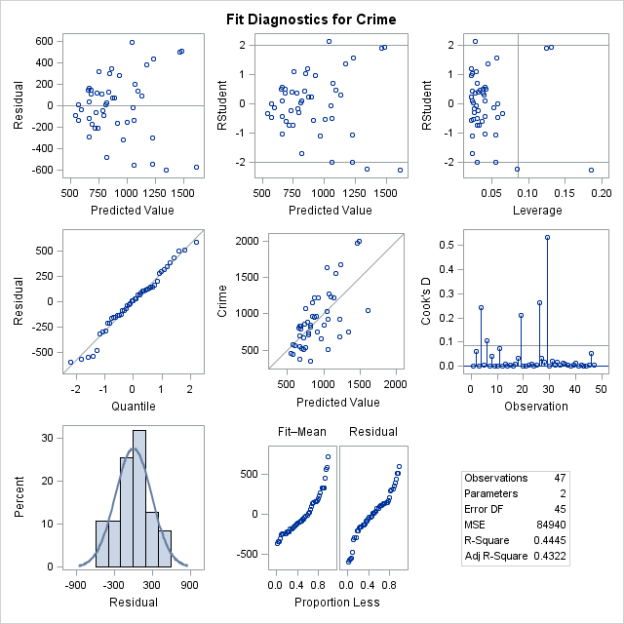

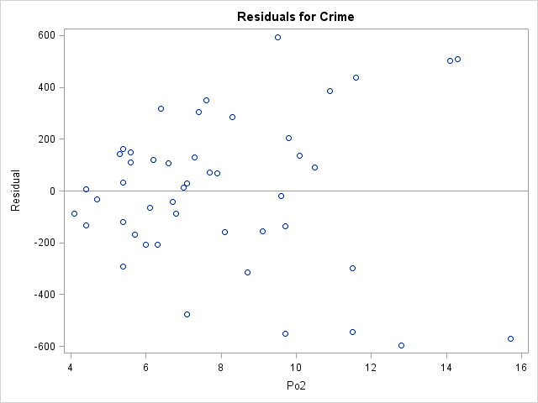

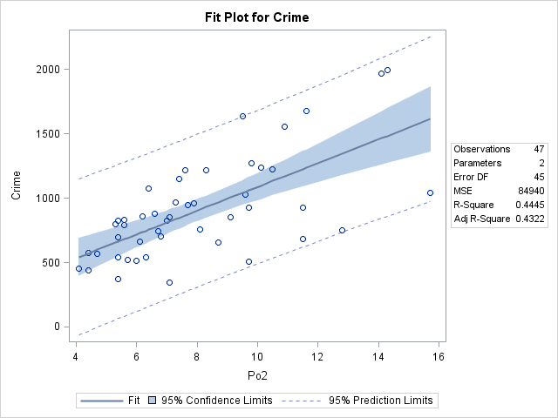

|  |
| --- |
| The SAS System |

The REG Procedure

Model: MODEL1

Dependent Variable: Crime

|  |  |
| --- | --- |
| **Number of Observations Read** | 47 |
| **Number of Observations Used** | 47 |

| **Analysis of Variance** | | | | | |
| --- | --- | --- | --- | --- | --- |
| **Source** | **DF** | **Sum of Squares** | **Mean Square** | **F Value** | **Pr > F** |
| **Model** | 1 | 245446 | 245446 | 1.66 | 0.2036 |
| **Error** | 45 | 6635482 | 147455 |  |  |
| **Corrected Total** | 46 | 6880928 |  |  |  |

|  |  |  |  |
| --- | --- | --- | --- |
| **Root MSE** | 383.99889 | **R-Square** | 0.0357 |
| **Dependent Mean** | 905.08511 | **Adj R-Sq** | 0.0142 |
| **Coeff Var** | 42.42683 |  |  |

| **Parameter Estimates** | | | | | |
| --- | --- | --- | --- | --- | --- |
| **Variable** | **DF** | **Parameter Estimate** | **Standard Error** | **t Value** | **Pr > |t|** |
| **Intercept** | **1** | -109.29773 | 788.23019 | -0.14 | 0.8903 |
| **LF** | **1** | 1807.55207 | 1401.01474 | 1.29 | 0.2036 |

|  |
| --- |
| The SAS System |

The REG Procedure

Model: MODEL1

Dependent Variable: Crime

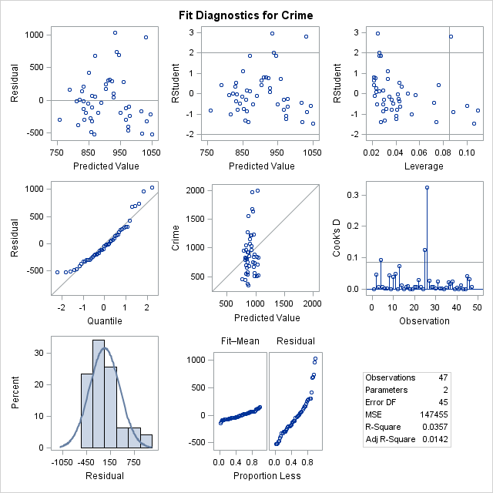

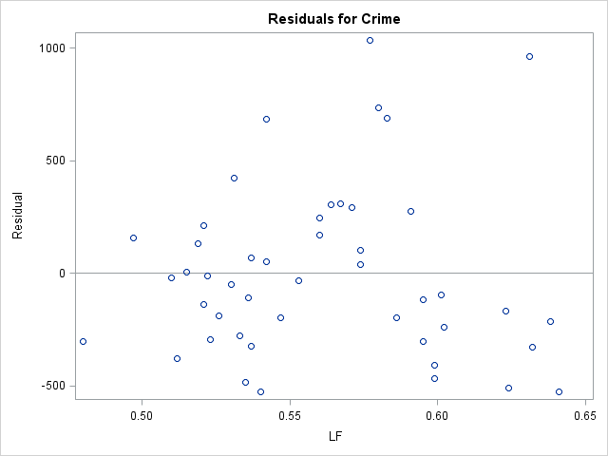

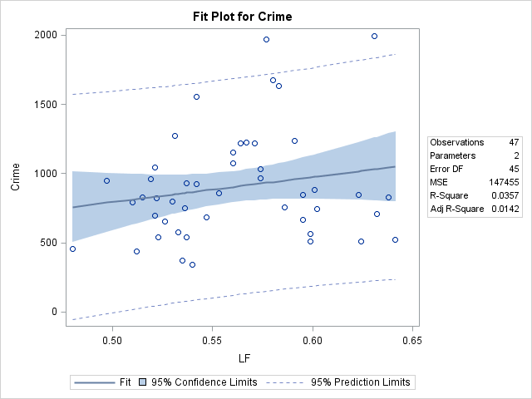

|  |
| --- |
| The SAS System |

The REG Procedure

Model: MODEL1

Dependent Variable: Crime

|  |  |
| --- | --- |
| **Number of Observations Read** | 47 |
| **Number of Observations Used** | 47 |

| **Analysis of Variance** | | | | | |
| --- | --- | --- | --- | --- | --- |
| **Source** | **DF** | **Sum of Squares** | **Mean Square** | **F Value** | **Pr > F** |
| **Model** | 1 | 314867 | 314867 | 2.16 | 0.1488 |
| **Error** | 45 | 6566061 | 145912 |  |  |
| **Corrected Total** | 46 | 6880928 |  |  |  |

|  |  |  |  |
| --- | --- | --- | --- |
| **Root MSE** | 381.98491 | **R-Square** | 0.0458 |
| **Dependent Mean** | 905.08511 | **Adj R-Sq** | 0.0246 |
| **Coeff Var** | 42.20431 |  |  |

| **Parameter Estimates** | | | | | |
| --- | --- | --- | --- | --- | --- |
| **Variable** | **DF** | **Parameter Estimate** | **Standard Error** | **t Value** | **Pr > |t|** |
| **Intercept** | **1** | -1854.89484 | 1879.66211 | -0.99 | 0.3290 |
| **MpF** | **1** | 28.07650 | 19.11287 | 1.47 | 0.1488 |

|  |
| --- |
| The SAS System |

The REG Procedure

Model: MODEL1

Dependent Variable: Crime

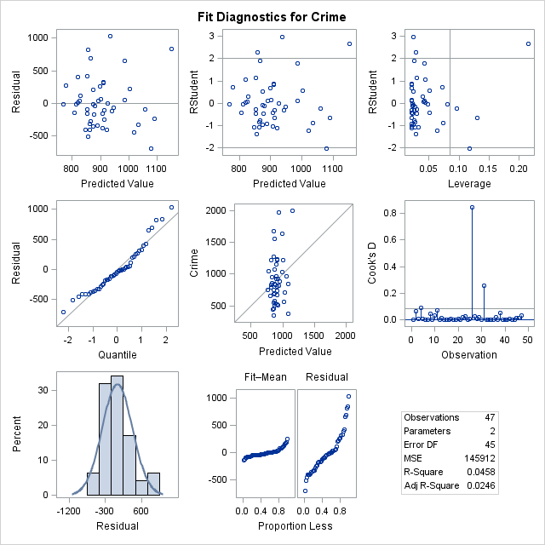

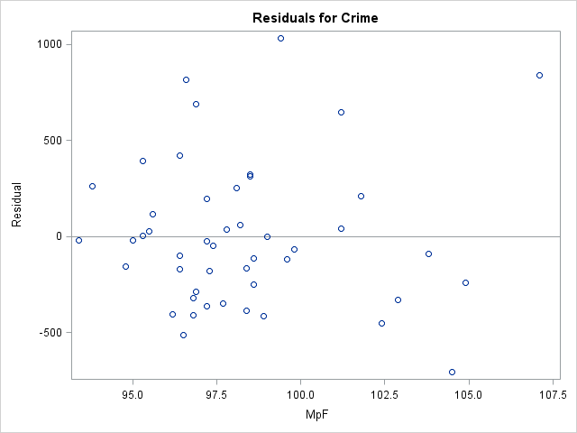

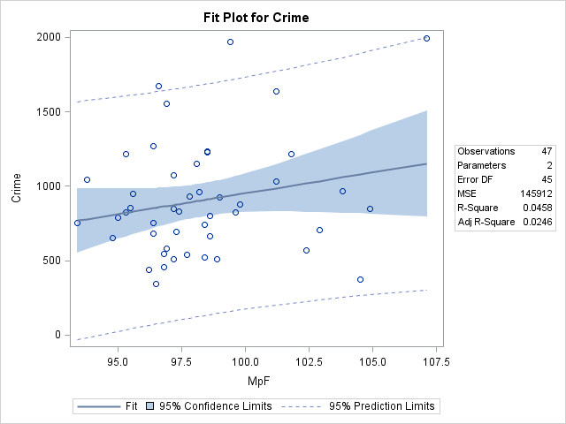

|  |
| --- |
| The SAS System |

The REG Procedure

Model: MODEL1

Dependent Variable: Crime

|  |  |
| --- | --- |
| **Number of Observations Read** | 47 |
| **Number of Observations Used** | 47 |

| **Analysis of Variance** | | | | | |
| --- | --- | --- | --- | --- | --- |
| **Source** | **DF** | **Sum of Squares** | **Mean Square** | **F Value** | **Pr > F** |
| **Model** | 1 | 783660 | 783660 | 5.78 | 0.0204 |
| **Error** | 45 | 6097267 | 135495 |  |  |
| **Corrected Total** | 46 | 6880928 |  |  |  |

|  |  |  |  |
| --- | --- | --- | --- |
| **Root MSE** | 368.09623 | **R-Square** | 0.1139 |
| **Dependent Mean** | 905.08511 | **Adj R-Sq** | 0.0942 |
| **Coeff Var** | 40.66979 |  |  |

| **Parameter Estimates** | | | | | |
| --- | --- | --- | --- | --- | --- |
| **Variable** | **DF** | **Parameter Estimate** | **Standard Error** | **t Value** | **Pr > |t|** |
| **Intercept** | **1** | 779.54816 | 74.88451 | 10.41 | <.0001 |
| **Pop** | **1** | 3.42838 | 1.42556 | 2.40 | 0.0204 |

|  |
| --- |
| The SAS System |

The REG Procedure

Model: MODEL1

Dependent Variable: Crime

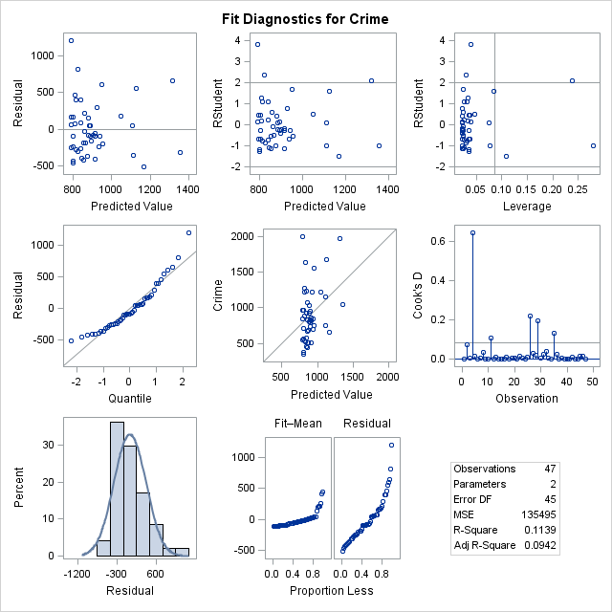

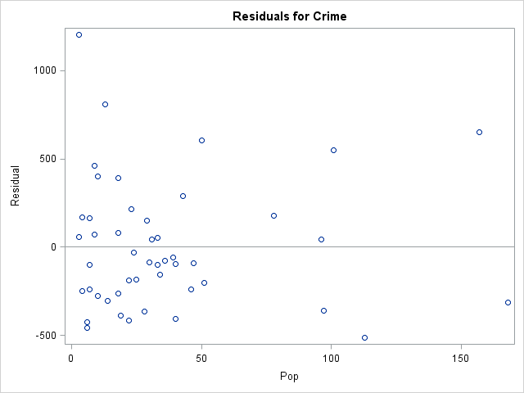

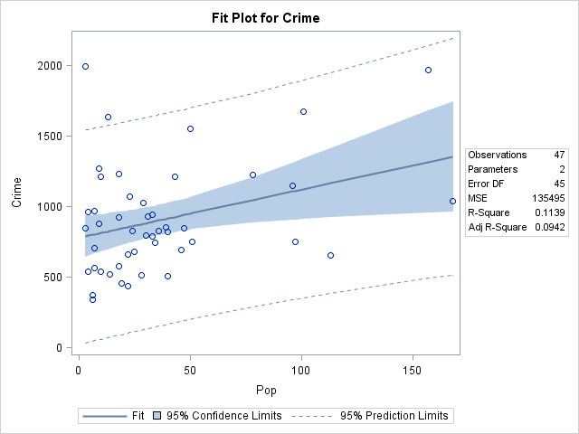

|  |
| --- |
| The SAS System |

The REG Procedure

Model: MODEL1

Dependent Variable: Crime

|  |  |
| --- | --- |
| **Number of Observations Read** | 47 |
| **Number of Observations Used** | 47 |

| **Analysis of Variance** | | | | | |
| --- | --- | --- | --- | --- | --- |
| **Source** | **DF** | **Sum of Squares** | **Mean Square** | **F Value** | **Pr > F** |
| **Model** | 1 | 7312.25249 | 7312.25249 | 0.05 | 0.8278 |
| **Error** | 45 | 6873615 | 152747 |  |  |
| **Corrected Total** | 46 | 6880928 |  |  |  |

|  |  |  |  |
| --- | --- | --- | --- |
| **Root MSE** | 390.82862 | **R-Square** | 0.0011 |
| **Dependent Mean** | 905.08511 | **Adj R-Sq** | -0.0211 |
| **Coeff Var** | 43.18142 |  |  |

| **Parameter Estimates** | | | | | |
| --- | --- | --- | --- | --- | --- |
| **Variable** | **DF** | **Parameter Estimate** | **Standard Error** | **t Value** | **Pr > |t|** |
| **Intercept** | **1** | 892.68567 | 80.38385 | 11.11 | <.0001 |
| **NW** | **1** | 1.22612 | 5.60393 | 0.22 | 0.8278 |

|  |
| --- |
| The SAS System |

The REG Procedure

Model: MODEL1

Dependent Variable: Crime

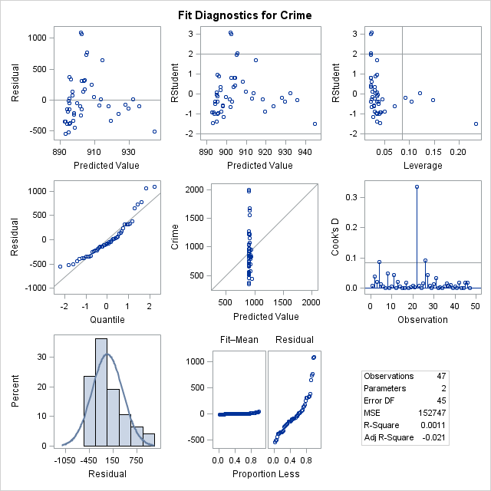

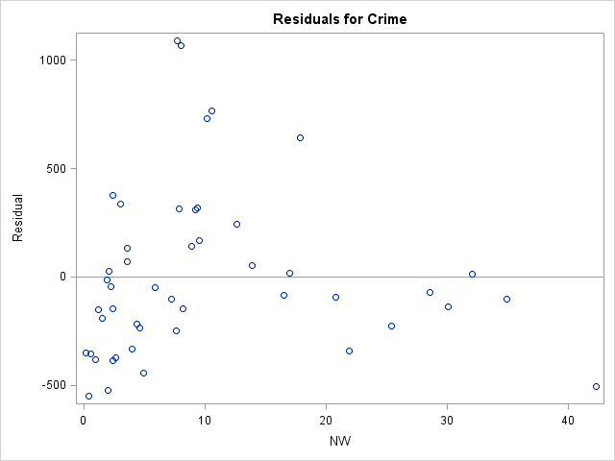

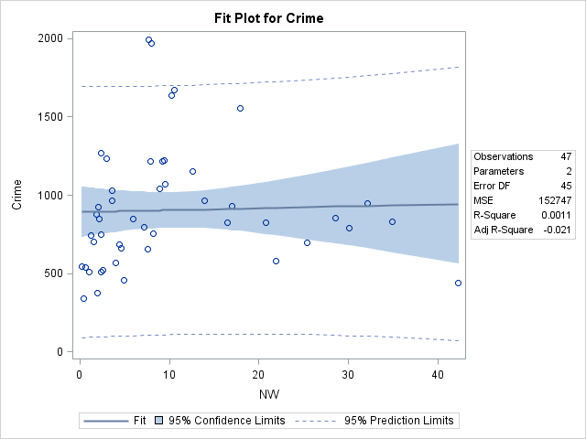

|  |
| --- |
| The SAS System |

The REG Procedure

Model: MODEL1

Dependent Variable: Crime

|  |  |
| --- | --- |
| **Number of Observations Read** | 47 |
| **Number of Observations Used** | 47 |

| **Analysis of Variance** | | | | | |
| --- | --- | --- | --- | --- | --- |
| **Source** | **DF** | **Sum of Squares** | **Mean Square** | **F Value** | **Pr > F** |
| **Model** | 1 | 17533 | 17533 | 0.11 | 0.7362 |
| **Error** | 45 | 6863395 | 152520 |  |  |
| **Corrected Total** | 46 | 6880928 |  |  |  |

|  |  |  |  |
| --- | --- | --- | --- |
| **Root MSE** | 390.53795 | **R-Square** | 0.0025 |
| **Dependent Mean** | 905.08511 | **Adj R-Sq** | -0.0196 |
| **Coeff Var** | 43.14931 |  |  |

| **Parameter Estimates** | | | | | |
| --- | --- | --- | --- | --- | --- |
| **Variable** | **DF** | **Parameter Estimate** | **Standard Error** | **t Value** | **Pr > |t|** |
| **Intercept** | **1** | 1008.46541 | 310.18885 | 3.25 | 0.0022 |
| **U1** | **1** | -1082.87820 | 3193.87503 | -0.34 | 0.7362 |

|  |
| --- |
| The SAS System |

The REG Procedure

Model: MODEL1

Dependent Variable: Crime

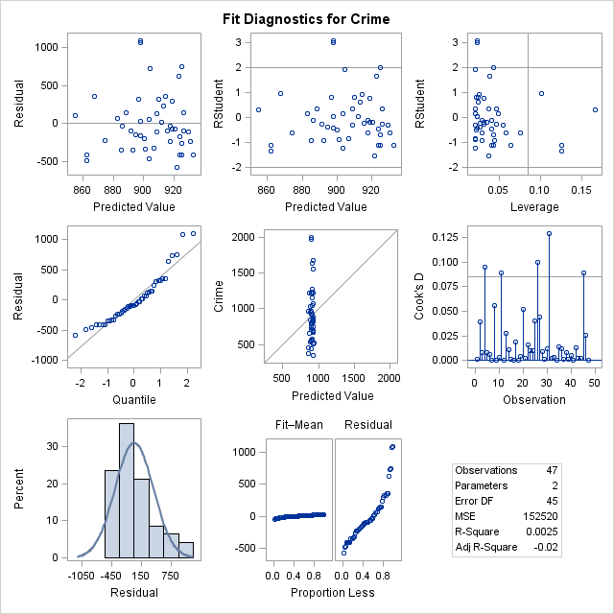

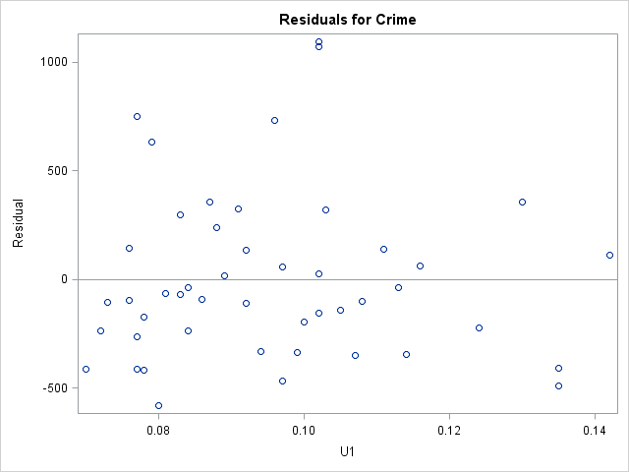

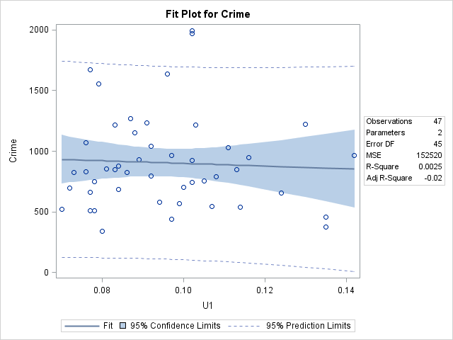

|  |
| --- |
| The SAS System |

The REG Procedure

Model: MODEL1

Dependent Variable: Crime

|  |  |
| --- | --- |
| **Number of Observations Read** | 47 |
| **Number of Observations Used** | 47 |

| **Analysis of Variance** | | | | | |
| --- | --- | --- | --- | --- | --- |
| **Source** | **DF** | **Sum of Squares** | **Mean Square** | **F Value** | **Pr > F** |
| **Model** | 1 | 216354 | 216354 | 1.46 | 0.2331 |
| **Error** | 45 | 6664573 | 148102 |  |  |
| **Corrected Total** | 46 | 6880928 |  |  |  |

|  |  |  |  |
| --- | --- | --- | --- |
| **Root MSE** | 384.83975 | **R-Square** | 0.0314 |
| **Dependent Mean** | 905.08511 | **Adj R-Sq** | 0.0099 |
| **Coeff Var** | 42.51973 |  |  |

| **Parameter Estimates** | | | | | |
| --- | --- | --- | --- | --- | --- |
| **Variable** | **DF** | **Parameter Estimate** | **Standard Error** | **t Value** | **Pr > |t|** |
| **Intercept** | **1** | 629.16195 | 235.08942 | 2.68 | 0.0103 |
| **U2** | **1** | 81.20469 | 67.18591 | 1.21 | 0.2331 |

|  |
| --- |
| The SAS System |

The REG Procedure

Model: MODEL1

Dependent Variable: Crime

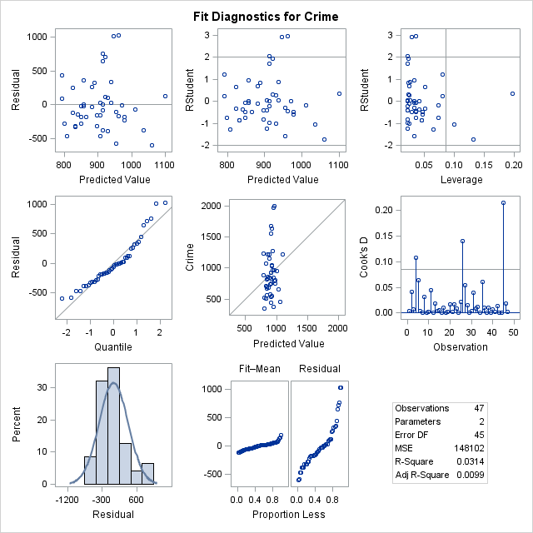

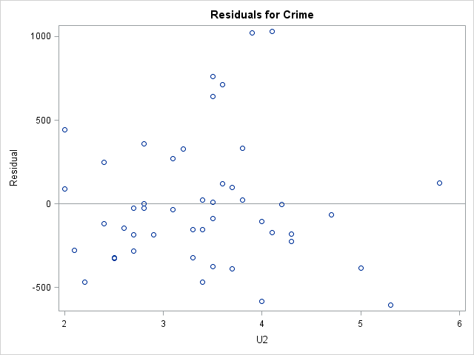

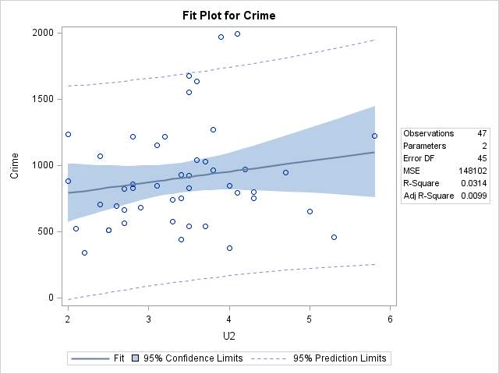

|  |
| --- |
| The SAS System |

The REG Procedure

Model: MODEL1

Dependent Variable: Crime

|  |  |
| --- | --- |
| **Number of Observations Read** | 47 |
| **Number of Observations Used** | 47 |

| **Analysis of Variance** | | | | | |
| --- | --- | --- | --- | --- | --- |
| **Source** | **DF** | **Sum of Squares** | **Mean Square** | **F Value** | **Pr > F** |
| **Model** | 1 | 1340152 | 1340152 | 10.88 | 0.0019 |
| **Error** | 45 | 5540775 | 123128 |  |  |
| **Corrected Total** | 46 | 6880928 |  |  |  |

|  |  |  |  |
| --- | --- | --- | --- |
| **Root MSE** | 350.89649 | **R-Square** | 0.1948 |
| **Dependent Mean** | 905.08511 | **Adj R-Sq** | 0.1769 |
| **Coeff Var** | 38.76945 |  |  |

| **Parameter Estimates** | | | | | |
| --- | --- | --- | --- | --- | --- |
| **Variable** | **DF** | **Parameter Estimate** | **Standard Error** | **t Value** | **Pr > |t|** |
| **Intercept** | **1** | -24.28261 | 286.31386 | -0.08 | 0.9328 |
| **Wealth** | **1** | 0.17689 | 0.05362 | 3.30 | 0.0019 |

|  |
| --- |
| The SAS System |

The REG Procedure

Model: MODEL1

Dependent Variable: Crime

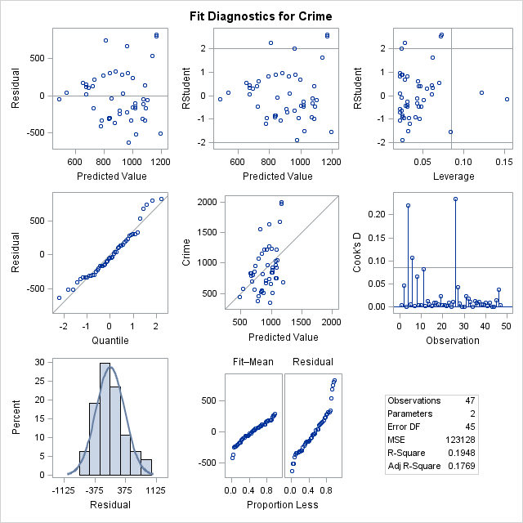

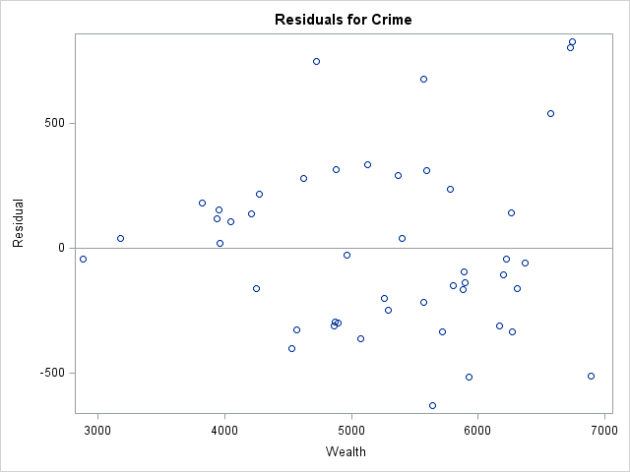

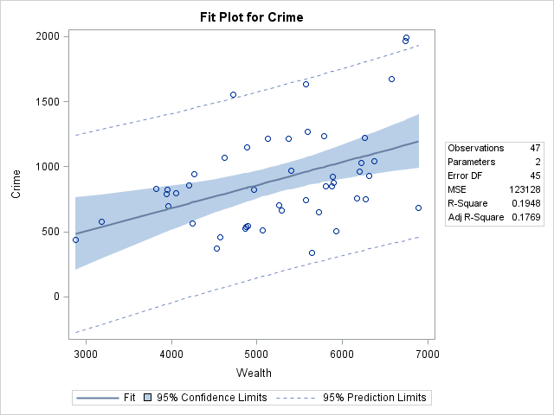

|  |
| --- |
| The SAS System |

The REG Procedure

Model: MODEL1

Dependent Variable: Crime

|  |  |
| --- | --- |
| **Number of Observations Read** | 47 |
| **Number of Observations Used** | 47 |

| **Analysis of Variance** | | | | | |
| --- | --- | --- | --- | --- | --- |
| **Source** | **DF** | **Sum of Squares** | **Mean Square** | **F Value** | **Pr > F** |
| **Model** | 1 | 220530 | 220530 | 1.49 | 0.2286 |
| **Error** | 45 | 6660397 | 148009 |  |  |
| **Corrected Total** | 46 | 6880928 |  |  |  |

|  |  |  |  |
| --- | --- | --- | --- |
| **Root MSE** | 384.71916 | **R-Square** | 0.0320 |
| **Dependent Mean** | 905.08511 | **Adj R-Sq** | 0.0105 |
| **Coeff Var** | 42.50641 |  |  |

| **Parameter Estimates** | | | | | |
| --- | --- | --- | --- | --- | --- |
| **Variable** | **DF** | **Parameter Estimate** | **Standard Error** | **t Value** | **Pr > |t|** |
| **Intercept** | **1** | 1241.77253 | 281.47753 | 4.41 | <.0001 |
| **Ineq** | **1** | -17.35502 | 14.21788 | -1.22 | 0.2286 |

|  |
| --- |
| The SAS System |

The REG Procedure

Model: MODEL1

Dependent Variable: Crime

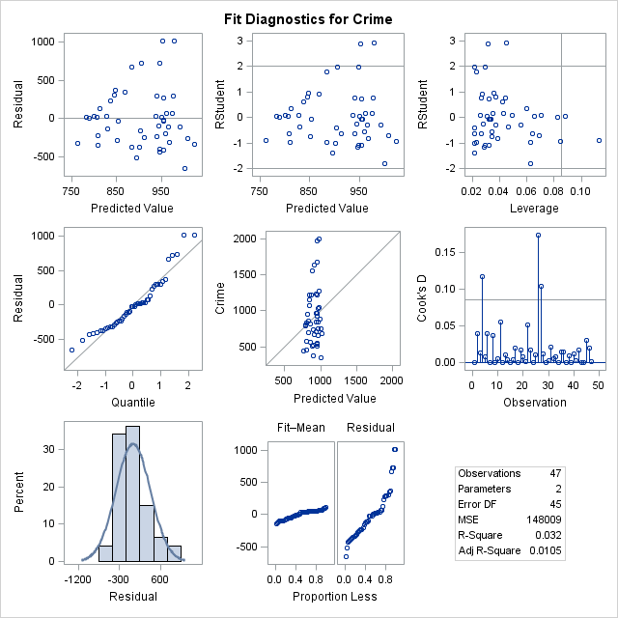

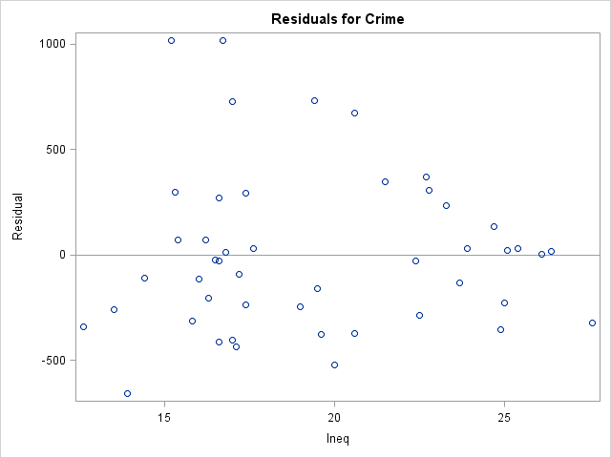

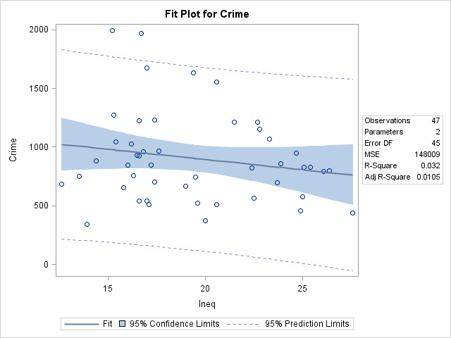

|  |
| --- |
| The SAS System |

The REG Procedure

Model: MODEL1

Dependent Variable: Crime

|  |  |
| --- | --- |
| **Number of Observations Read** | 47 |
| **Number of Observations Used** | 47 |

| **Analysis of Variance** | | | | | |
| --- | --- | --- | --- | --- | --- |
| **Source** | **DF** | **Sum of Squares** | **Mean Square** | **F Value** | **Pr > F** |
| **Model** | 1 | 1257075 | 1257075 | 10.06 | 0.0027 |
| **Error** | 45 | 5623853 | 124975 |  |  |
| **Corrected Total** | 46 | 6880928 |  |  |  |

|  |  |  |  |
| --- | --- | --- | --- |
| **Root MSE** | 353.51734 | **R-Square** | 0.1827 |
| **Dependent Mean** | 905.08511 | **Adj R-Sq** | 0.1645 |
| **Coeff Var** | 39.05902 |  |  |

| **Parameter Estimates** | | | | | |
| --- | --- | --- | --- | --- | --- |
| **Variable** | **DF** | **Parameter Estimate** | **Standard Error** | **t Value** | **Pr > |t|** |
| **Intercept** | **1** | 1247.46674 | 119.63778 | 10.43 | <.0001 |
| **Prob** | **1** | -7270.57925 | 2292.44630 | -3.17 | 0.0027 |

|  |
| --- |
| The SAS System |

The REG Procedure

Model: MODEL1

Dependent Variable: Crime

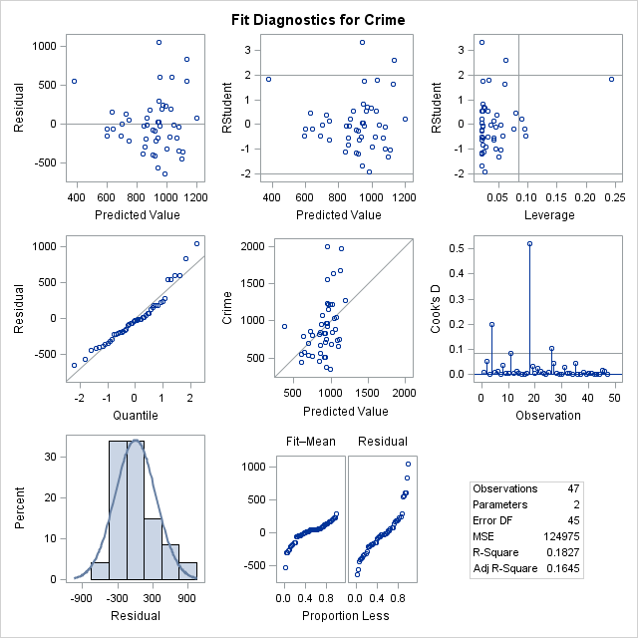

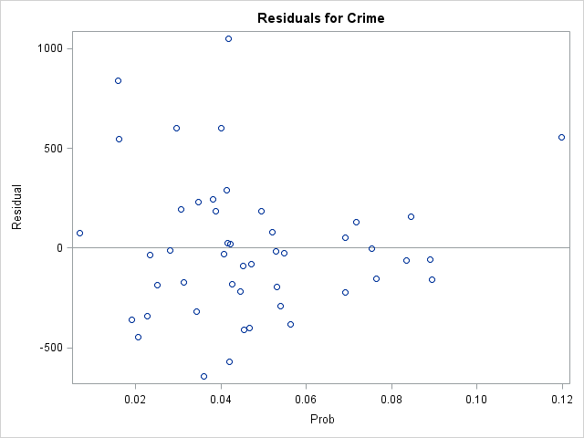

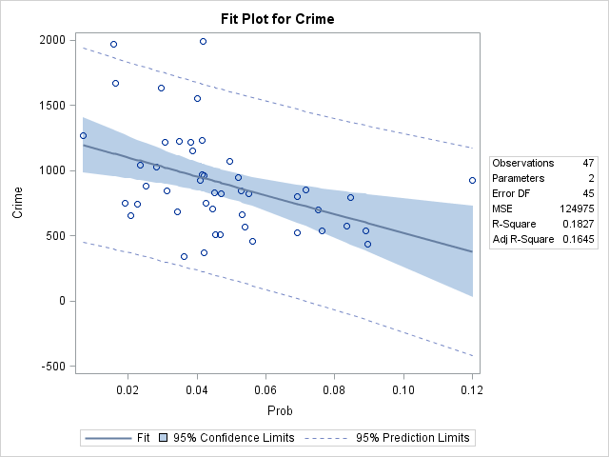

|  |
| --- |
| The SAS System |

The REG Procedure

Model: MODEL1

Dependent Variable: Crime

|  |  |
| --- | --- |
| **Number of Observations Read** | 47 |
| **Number of Observations Used** | 47 |

| **Analysis of Variance** | | | | | |
| --- | --- | --- | --- | --- | --- |
| **Source** | **DF** | **Sum of Squares** | **Mean Square** | **F Value** | **Pr > F** |
| **Model** | 1 | 154545 | 154545 | 1.03 | 0.3147 |
| **Error** | 45 | 6726383 | 149475 |  |  |
| **Corrected Total** | 46 | 6880928 |  |  |  |

|  |  |  |  |
| --- | --- | --- | --- |
| **Root MSE** | 386.62020 | **R-Square** | 0.0225 |
| **Dependent Mean** | 905.08511 | **Adj R-Sq** | 0.0007 |
| **Coeff Var** | 42.71645 |  |  |

| **Parameter Estimates** | | | | | |
| --- | --- | --- | --- | --- | --- |
| **Variable** | **DF** | **Parameter Estimate** | **Standard Error** | **t Value** | **Pr > |t|** |
| **Intercept** | **1** | 687.54489 | 221.25047 | 3.11 | 0.0033 |
| **Time** | **1** | 8.17884 | 8.04358 | 1.02 | 0.3147 |

|  |
| --- |
| The SAS System |

The REG Procedure

Model: MODEL1

Dependent Variable: Crime

